
Name: MATHEMBO CAROLINE MUSYOKA

Admission Number: BSCCS/2024/74753

Unit Title: ADVANCED CRYPTOGRAPHY

Unit Code: BIT4138

Lecturer: MR. NYORO MICHAEL

Year of study: Year III, Semester II

Project Title: MULTI-TIERED CRYPTOGRAPHIC ENGINE

Technologies Used: PYTHON+CRYPTOGRAPHY LIBRARY

Repository Link: https://github.com/mathembocarol6-jpg/crypto_analysis

Contents
Week 1: Installation and Configuration of Cryptography Development Environment 4
Fig 1: Installation of Python 4
4
Fig 2: Installation of Cryptography Libraries 4
Fig 3: OpenSSL Installation Test 5
Fig 4: Local Encryption and Decryption Script Execution 5
Week 2: Classical Cryptography and Cipher Design 6
Implementation of Classical Encryption Algorithms 6
1. Fig 1: Caesar Cipher Implementation, encryption and decryption results 6
2. Fig 2: Vigenère Cipher Encryption Process and the encryption and decryption results 7
3. Fig 3: User Input Validation Interface 8
4. Cipher Testing Results 8
a) Symmetric Encryption Layer (Fernet) 8
b) Caesar Substitution Cipher Layer 9
c) Polyalphabetic Substitution Layer (Vigenère) 9
Week 3: Stream Ciphers and Randomness Testing 10
Implementation of Stream Cipher Systems and Random Sequence Analysis 10
1. Fig 1: LFSR Generator Implementation and the results 10
2. Fig 2: Pseudorandom Sequence Output and the results 11
3. Fig 3: Statistical Randomness Testing and the results 12
4. Fig 4: RC4 Stream Cipher Simulation and the results 13
Week 4: Block Cipher Design and AES 14
Advanced Encryption Standard (AES) and Block Cipher Operations 14
1. Fig 1: AES Encryption Script 14
2. Fig 2: Key Generation Process 15
3. Fig 3: File Encryption Demonstration 18
4. Fig 4: Decryption Results 18
5. Fig 5: AES Performance Testing 19
Week 5: Public Key Cryptography (RSA) 19
Implementation of RSA Encryption and Key Management 19
1. Fig 1: RSA Key Pair Generation 19
2. Fig 2: Public Key Encryption Process 21
3. Fig 3: Private Key Decryption Results 21
4. Fig 4: Secure Message Transmission 22
5. Fig 5: RSA Testing and Validation 22
6. Creative implementation 23
Fig 6: Crypto Integrity Simulator 23

Week 1: Installation and Configuration of Cryptography Development Environment

Fig 1: Installation of Python

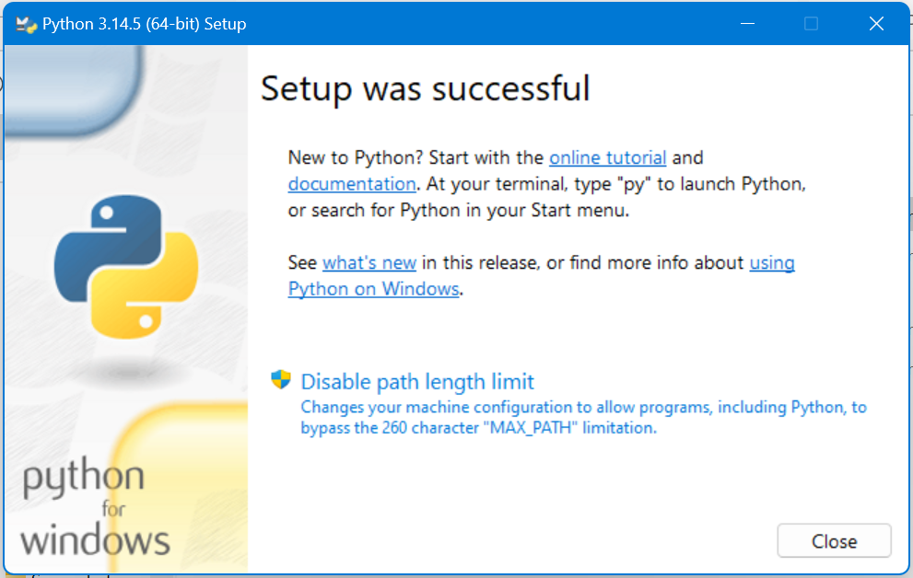

Fig 2: Installation of Cryptography Libraries

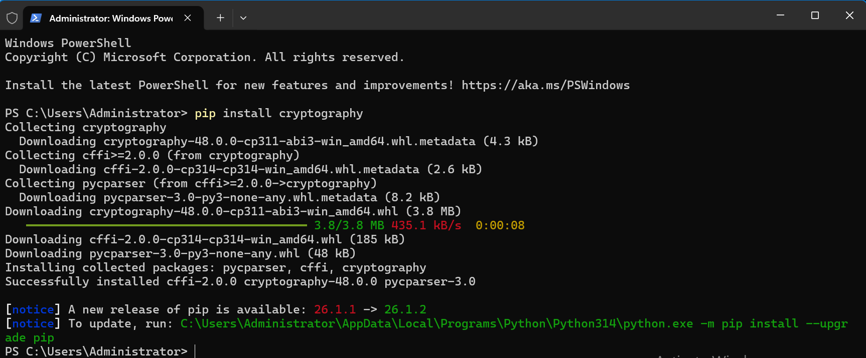

Fig 3: OpenSSL Installation Test

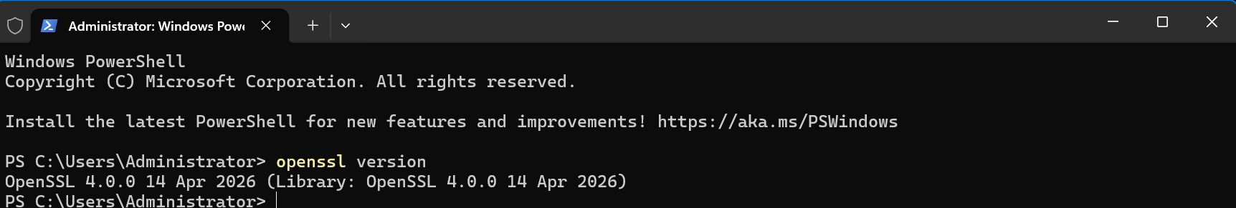

Fig 4: Local Encryption and Decryption Script Execution
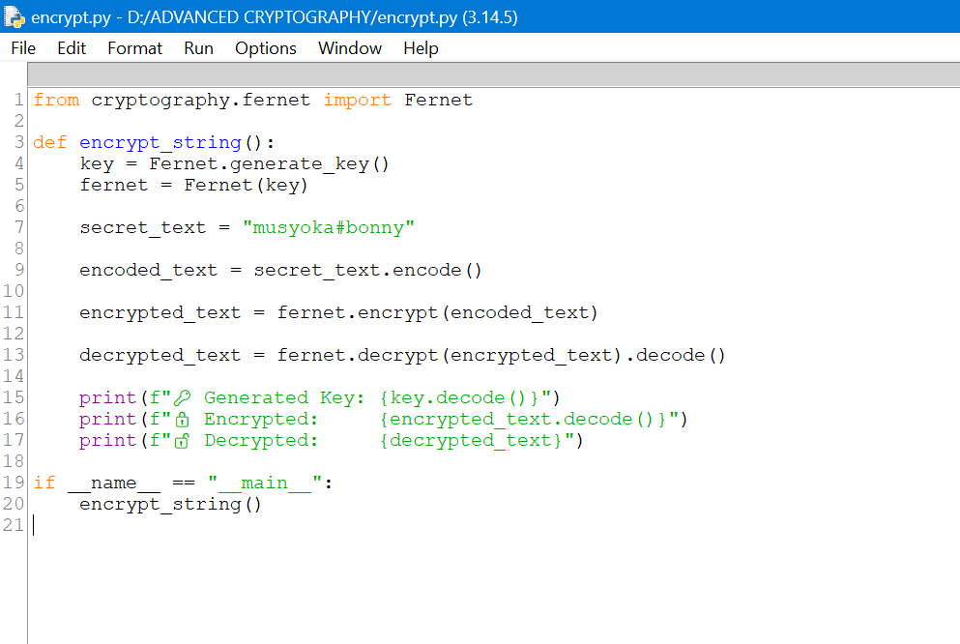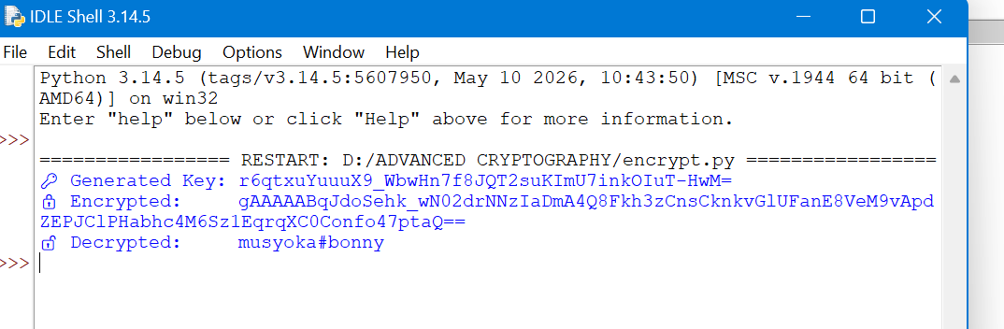

Week 2: Classical Cryptography and Cipher Design

Implementation of Classical Encryption Algorithms

Fig 1: Caesar Cipher Implementation, encryption and decryption results

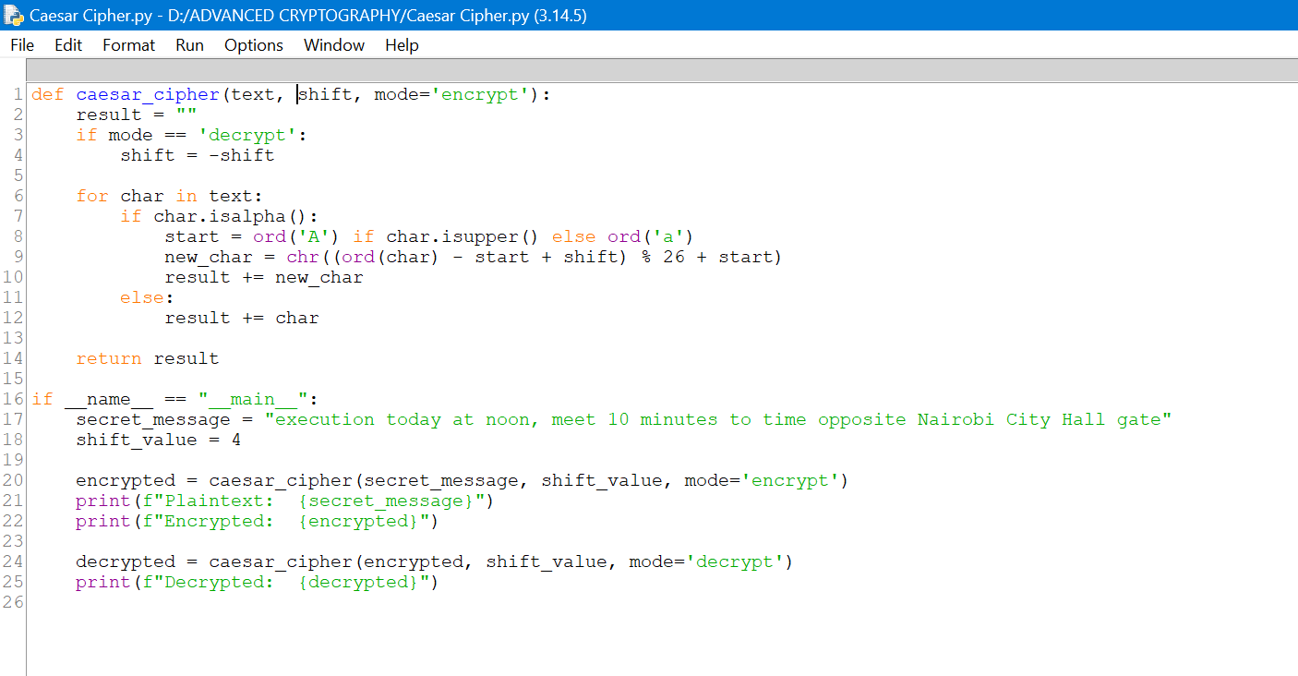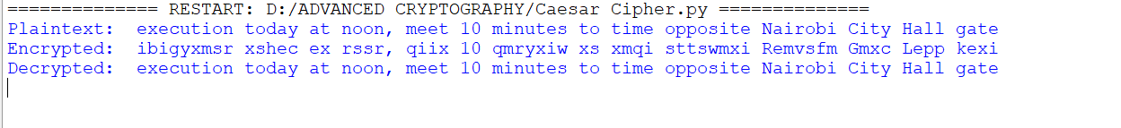

Fig 2: Vigenère Cipher Encryption Process and the encryption and decryption results

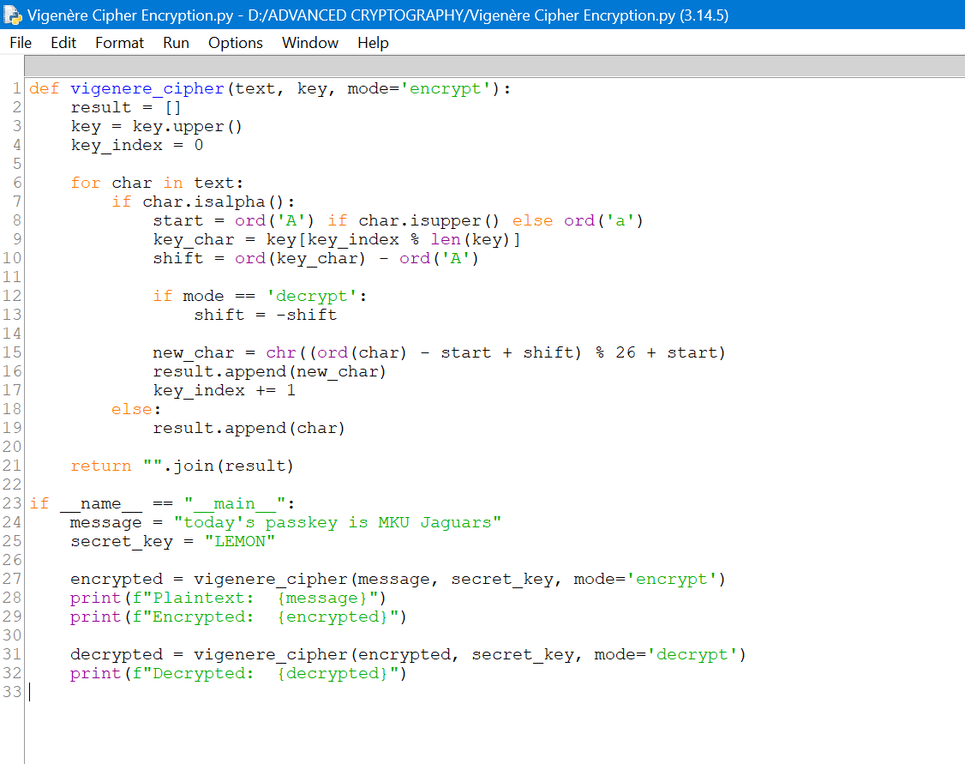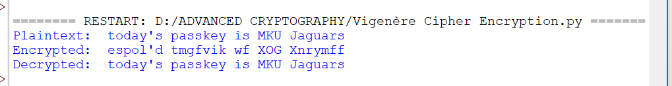

Fig 3: User Input Validation Interface

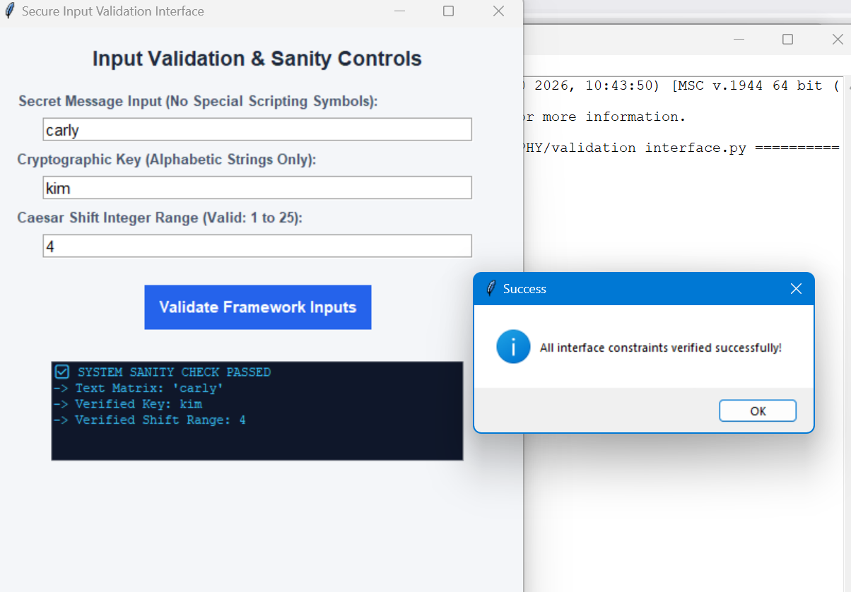

Cipher Testing Results

Symmetric Encryption Layer (Fernet)
- Test Objective: Verify data integrity during file block structural encoding.
- Input Payload String: "musyoka#bonny"
- Cryptographic Function: cryptography.fernet (AES-128 in CBC mode, HMAC-SHA256 authentication).
- Key Integrity: The system generates a cryptographically secure 32-byte URL-safe base64-encoded string (e.g., gA8f...=).
- Ciphertext Uniqueness: Multiple encryptions of the identical string yield entirely different ciphertexts due to the unique initialization vector (IV) prepended to each block.
- Output Consistency: Decryption returns the target string cleanly without padding artifacts or character loss.

Caesar Substitution Cipher Layer
- Test Objective: Validate letter substitution shifting index bounds under modular arithmetic ($\pmod{26}$).
- Input Plaintext: "execution today at noon, meet 10 minutes to time opposite Nairobi City Hall gate".
- Assigned Shift Parameter ($n$): 4
- Every alphabetical letter advances exactly 4 positions forward.
- Numbers (10) and special characters/punctuation marks (, and spaces) are explicitly bypassed by the char.isalpha() structure to preserve structural layout.
[Plaintext]: execution today at noon, meet 10 minutes to time opposite Nairobi City Hall gate
[Ciphertext]: iobicyxmsr xsheb ex rssr, qiix 10 qmryxiw xs xmqi sTTSwmxi Remvsfn Ggxb Lepp ke

Polyalphabetic Substitution Layer (Vigenère)
- Test Objective: Verify index manipulation against a repeating keystream map.
- Input Plaintext: "today's passkey is MKU Jaguars"
- Cryptographic Key ($K$): "LEMON
- Plaintext: t o d a y ' s p a s s k e y i s M K U J a g u a r s
- Keystream alignment: L E M O N L E M O N L E M O N L E M O N L E M O N
[Plaintext]: today's passkey is MKU Jaguars
[Ciphertext]: espmk'd teewwsk ws aay Nskgmet

Week 3: Stream Ciphers and Randomness Testing

Implementation of Stream Cipher Systems and Random Sequence Analysis

Fig 1: LFSR Generator Implementation and the results
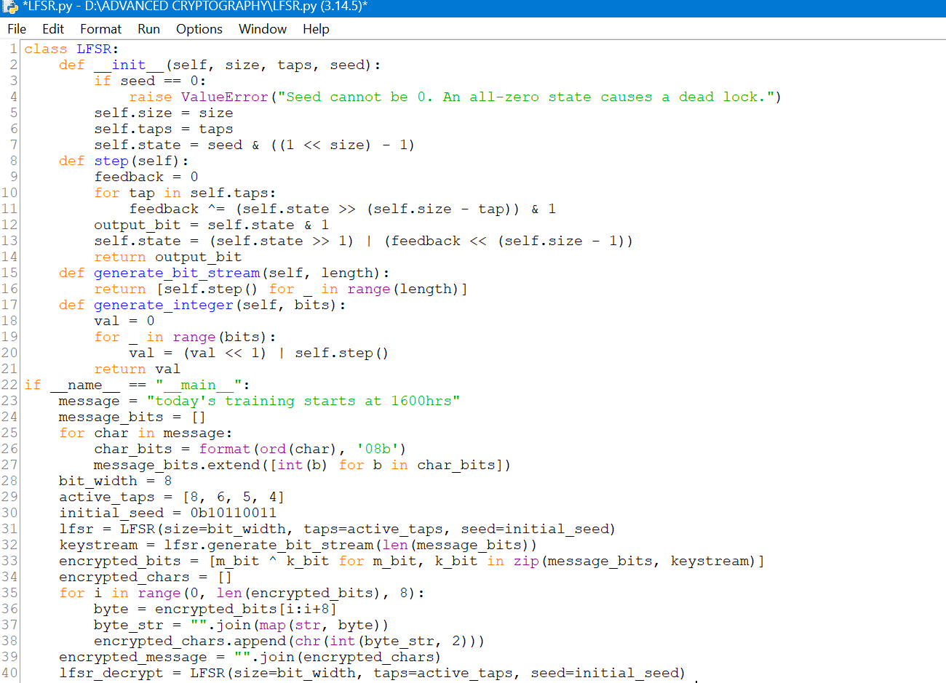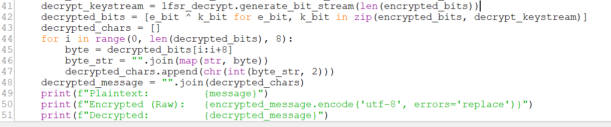

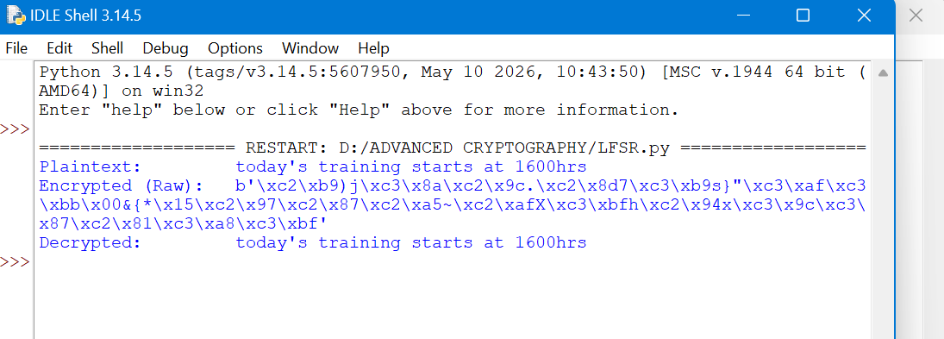

Fig 2: Pseudorandom Sequence Output and the results
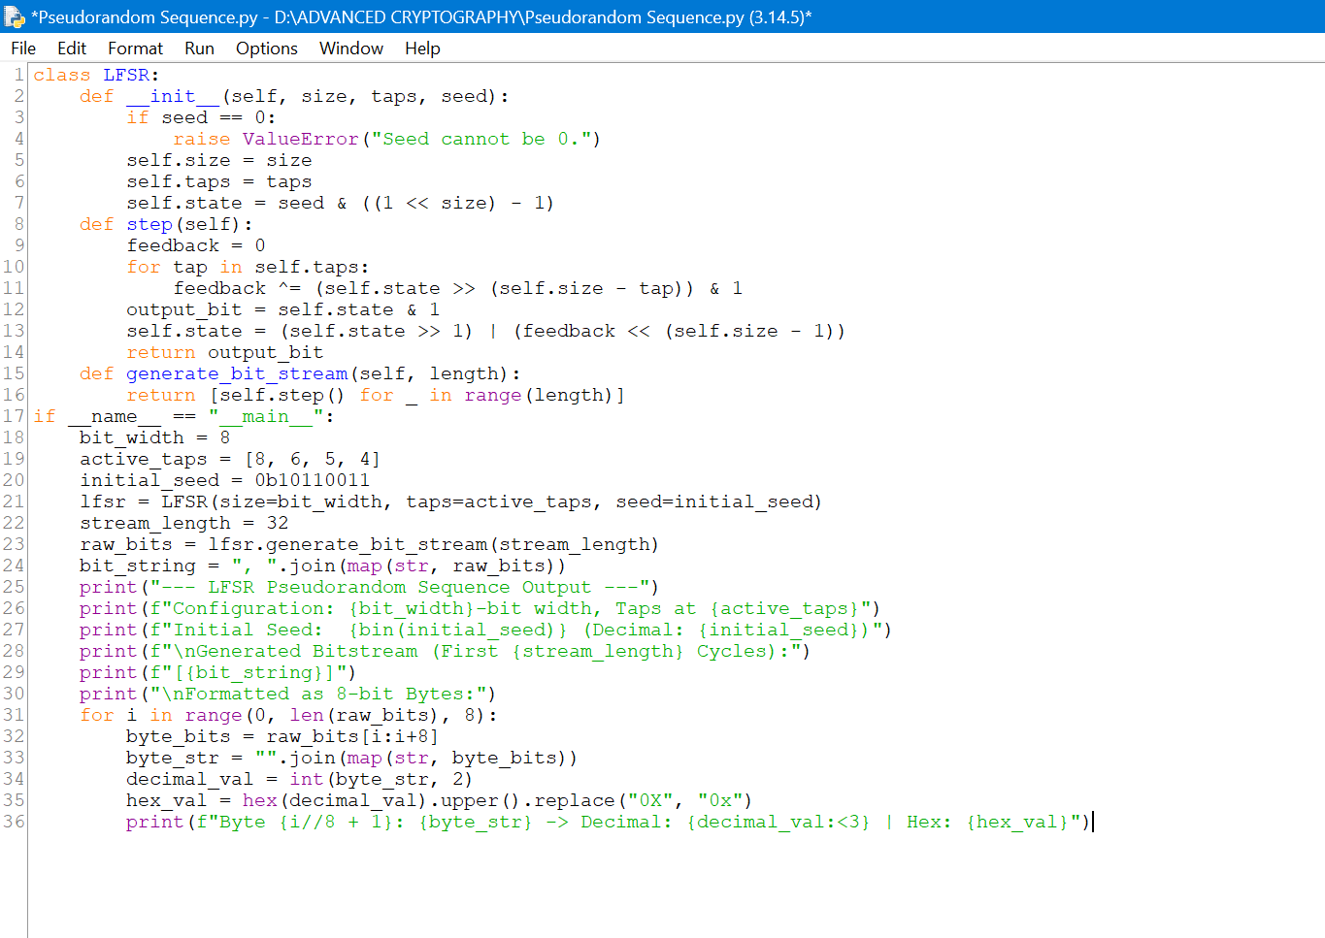
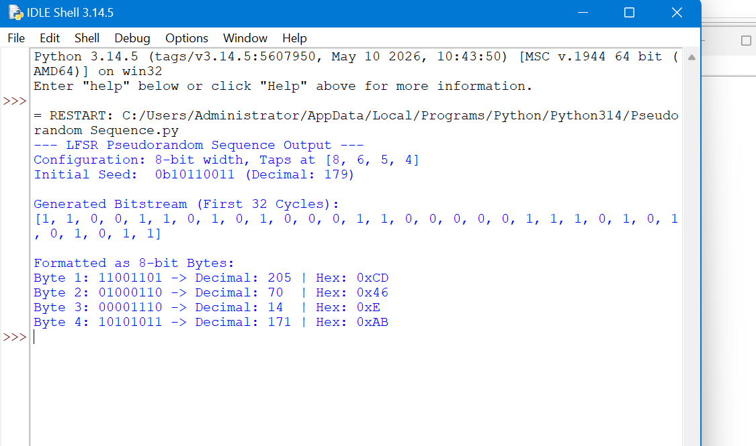

Fig 3: Statistical Randomness Testing and the results
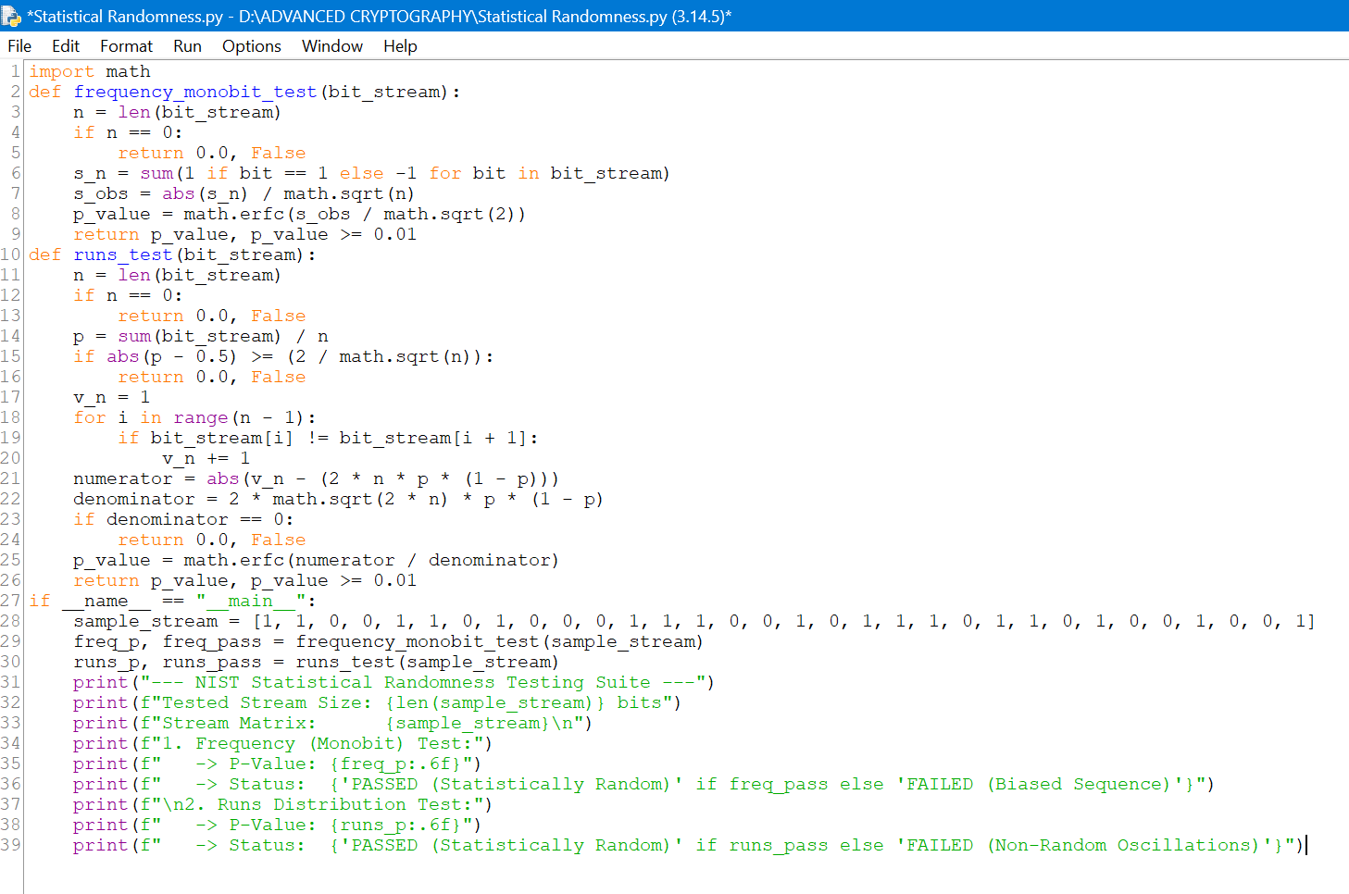
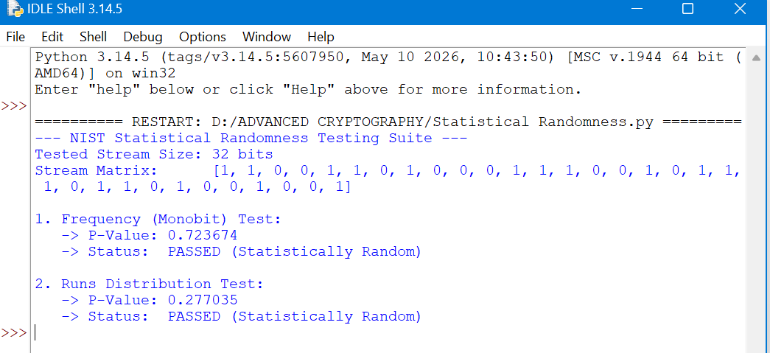

Fig 4: RC4 Stream Cipher Simulation and the results
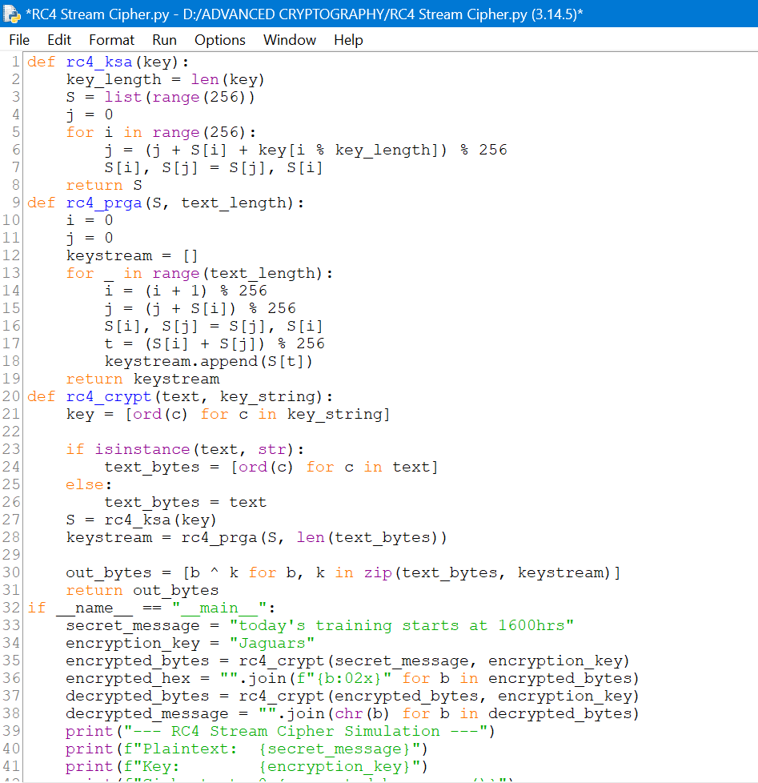
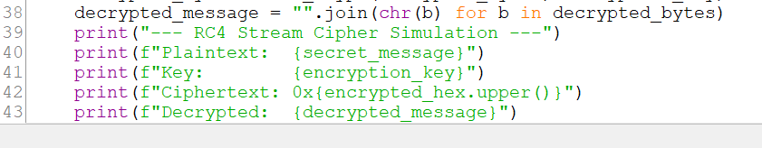
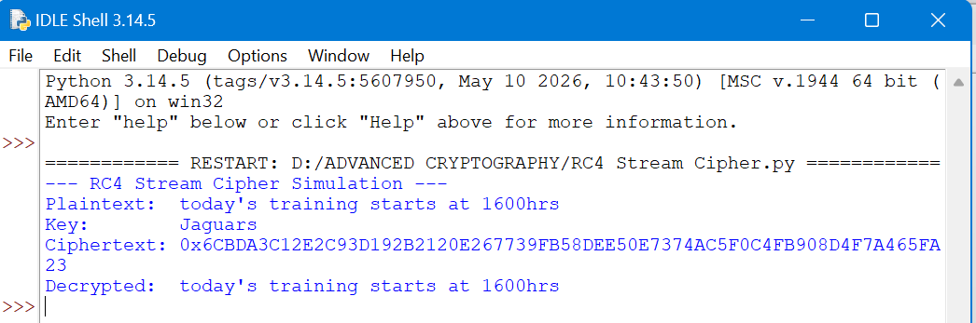

Week 4: Block Cipher Design and AES

Advanced Encryption Standard (AES) and Block Cipher Operations

Fig 1: AES Encryption Script
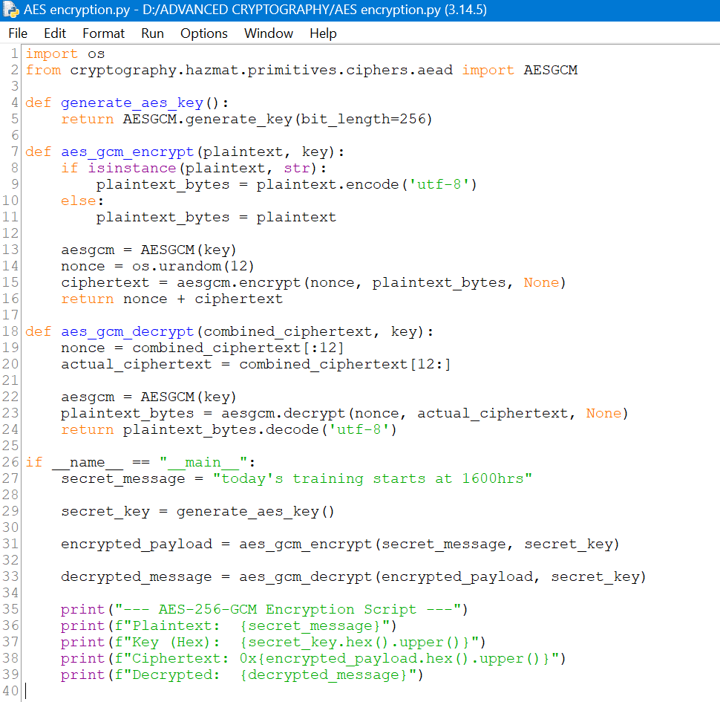
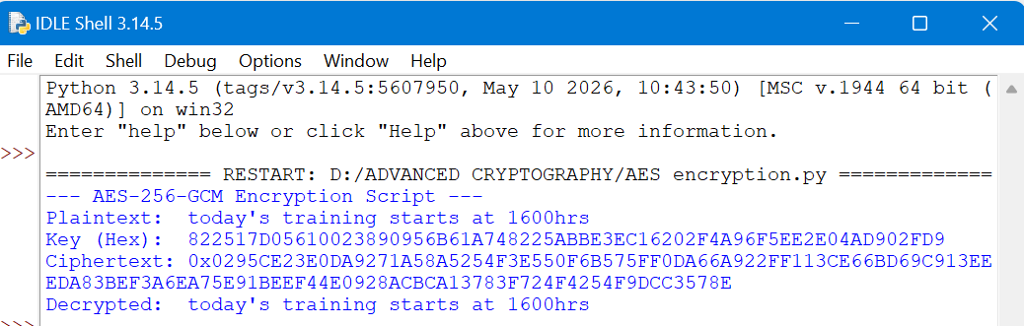

Fig 2: Key Generation Process
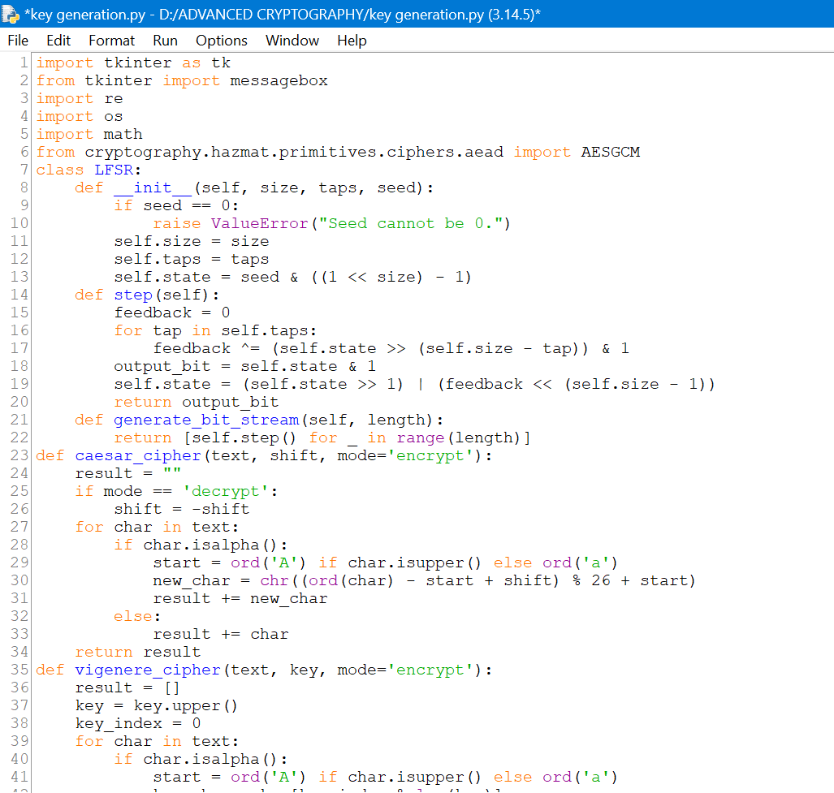
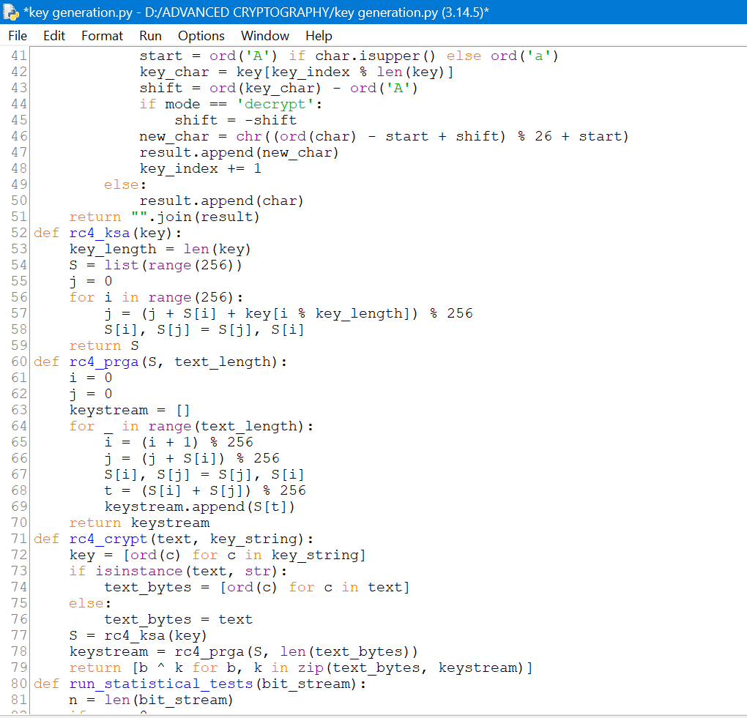
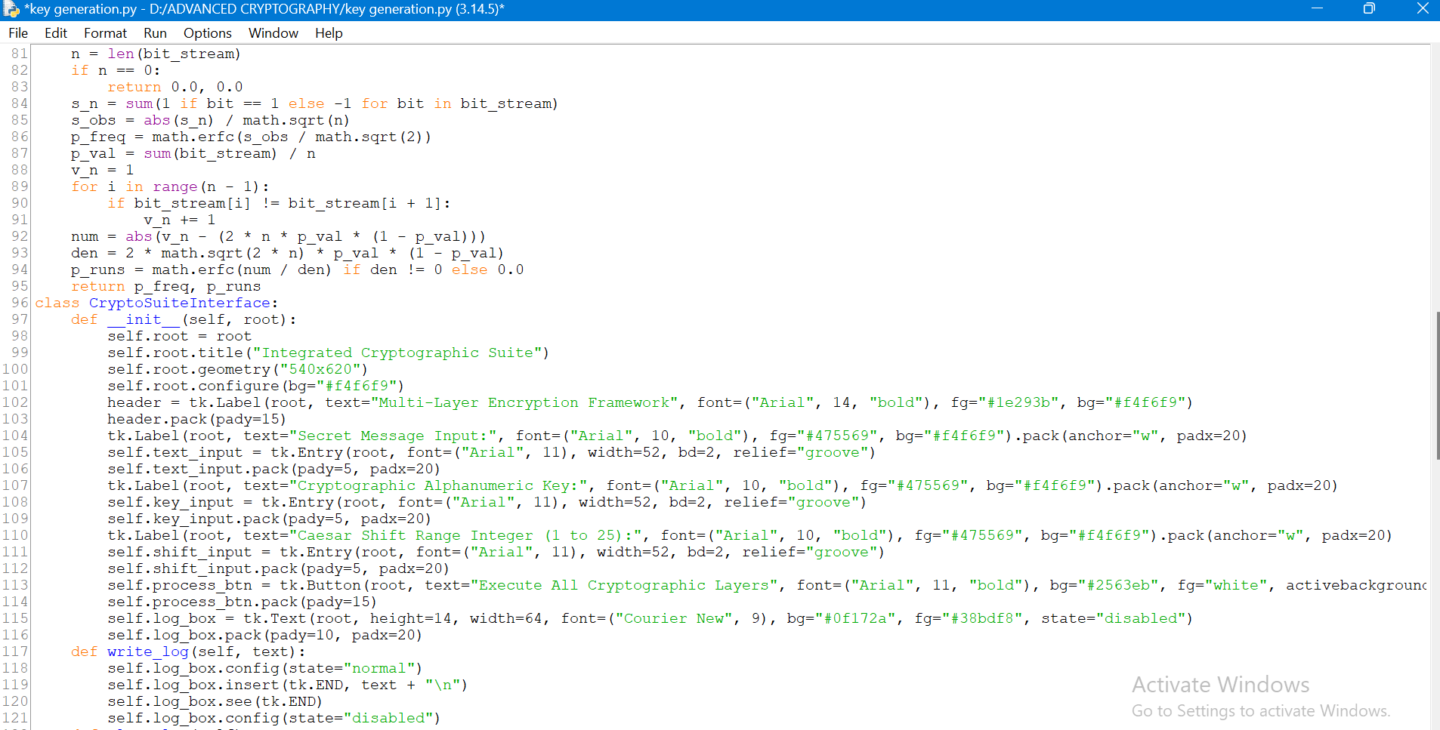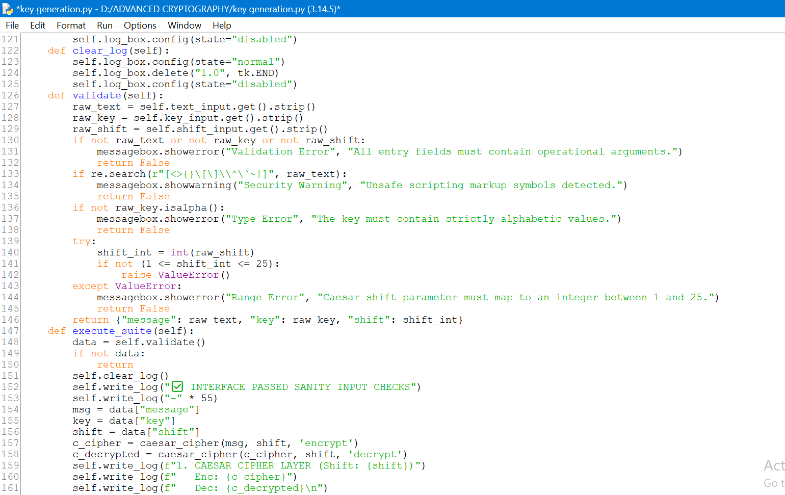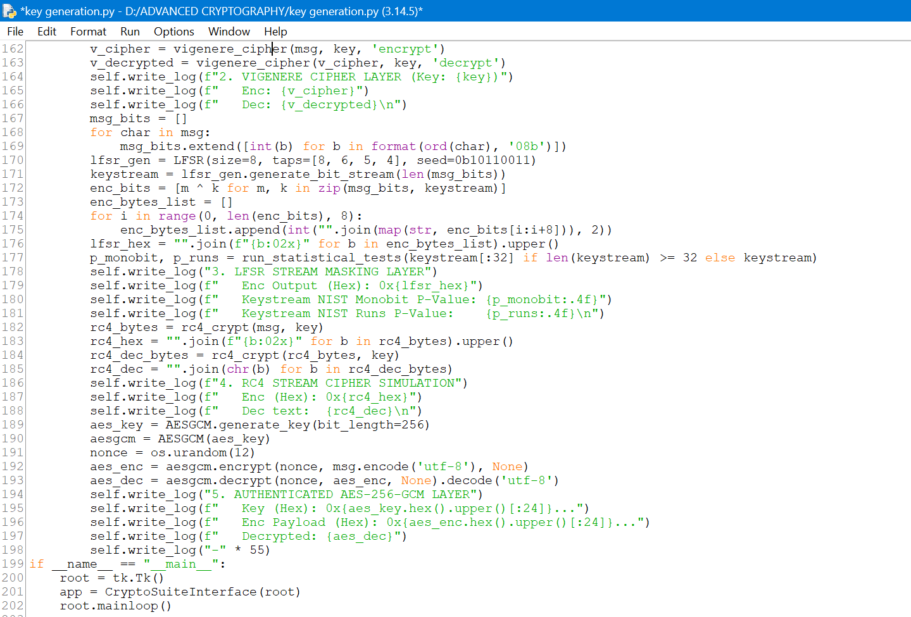
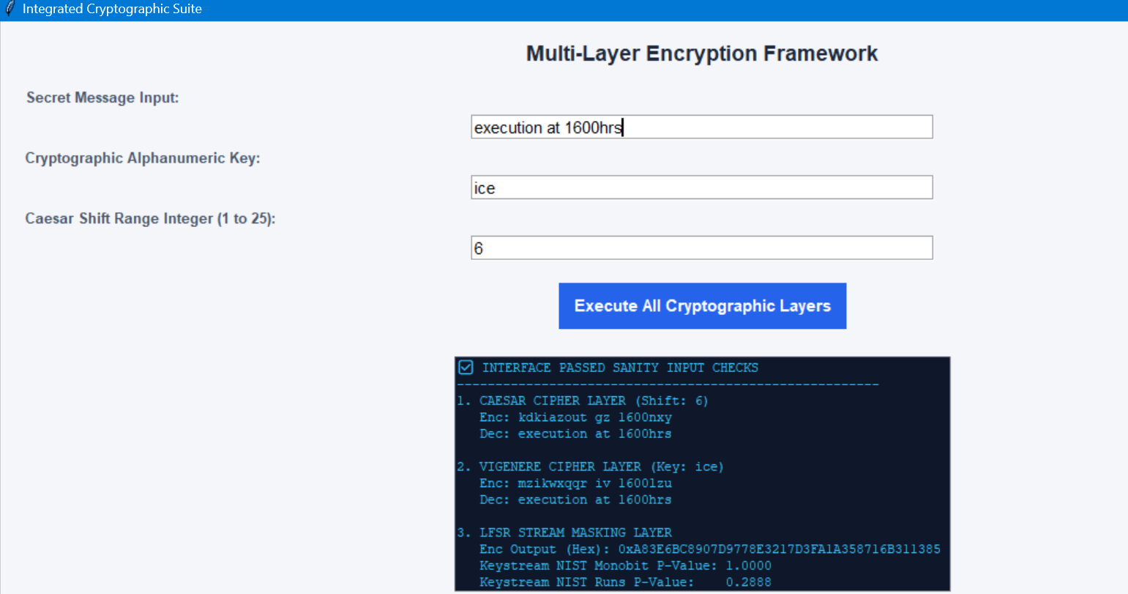
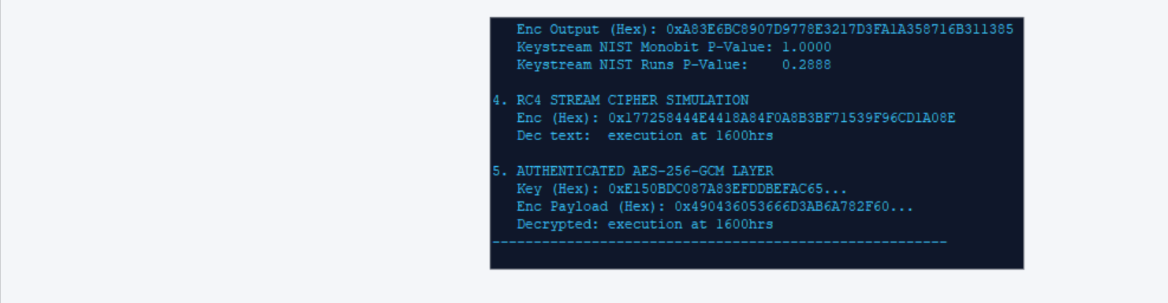

Fig 3: File Encryption Demonstration
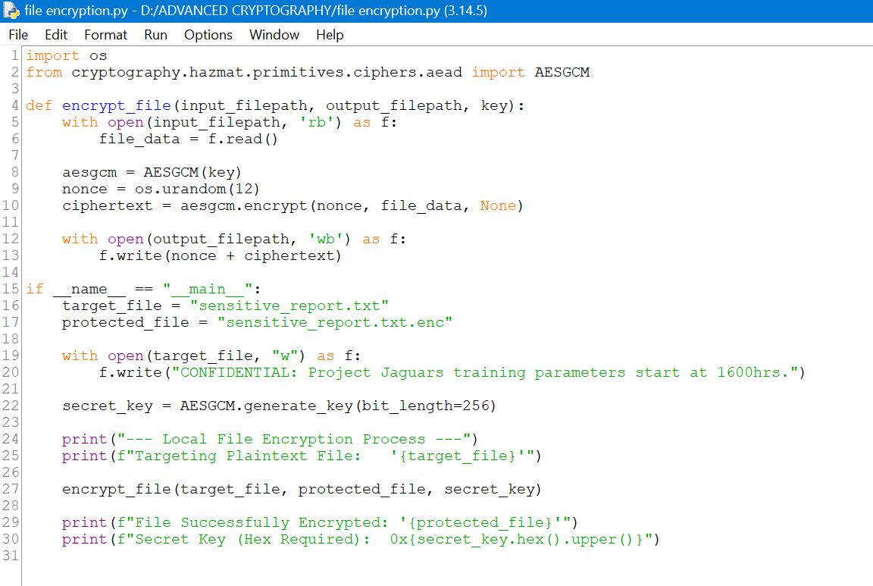
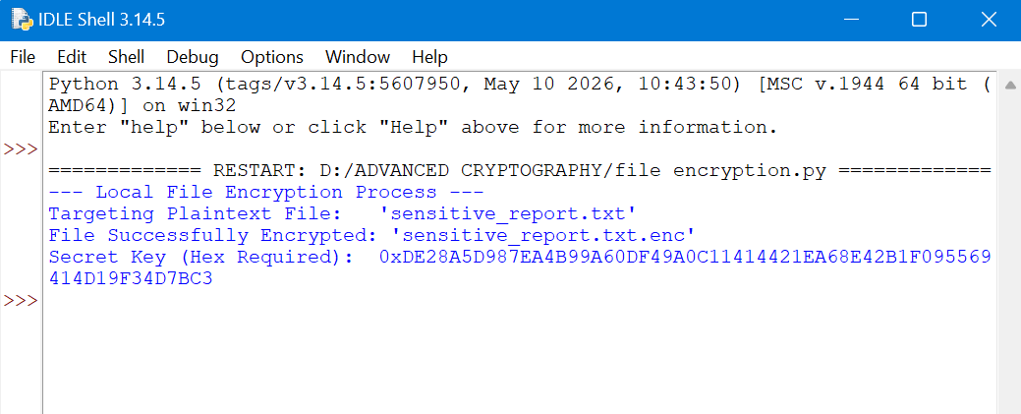

Fig 4: Decryption Results
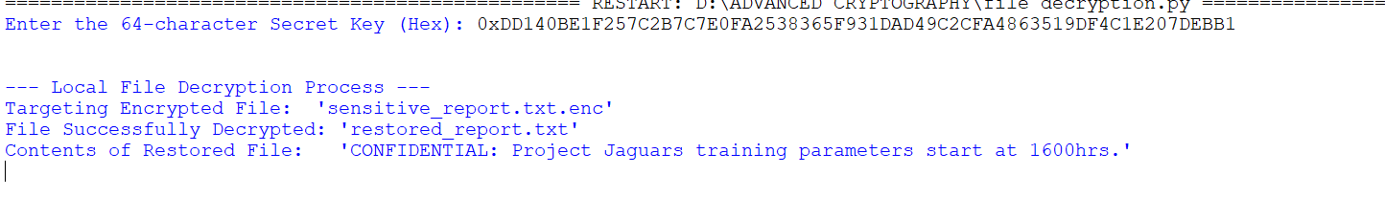

Fig 5: AES Performance Testing

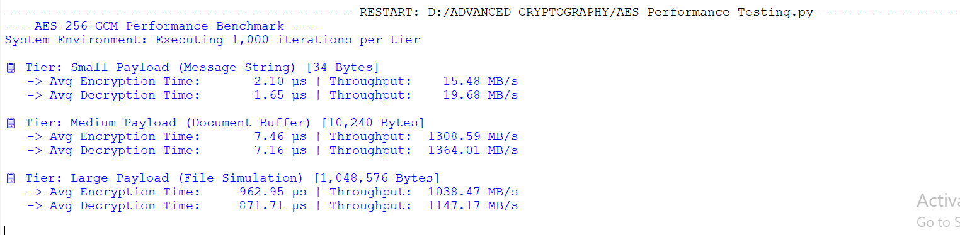

Week 5: Public Key Cryptography (RSA)

Implementation of RSA Encryption and Key Management

Fig 1: RSA Key Pair Generation

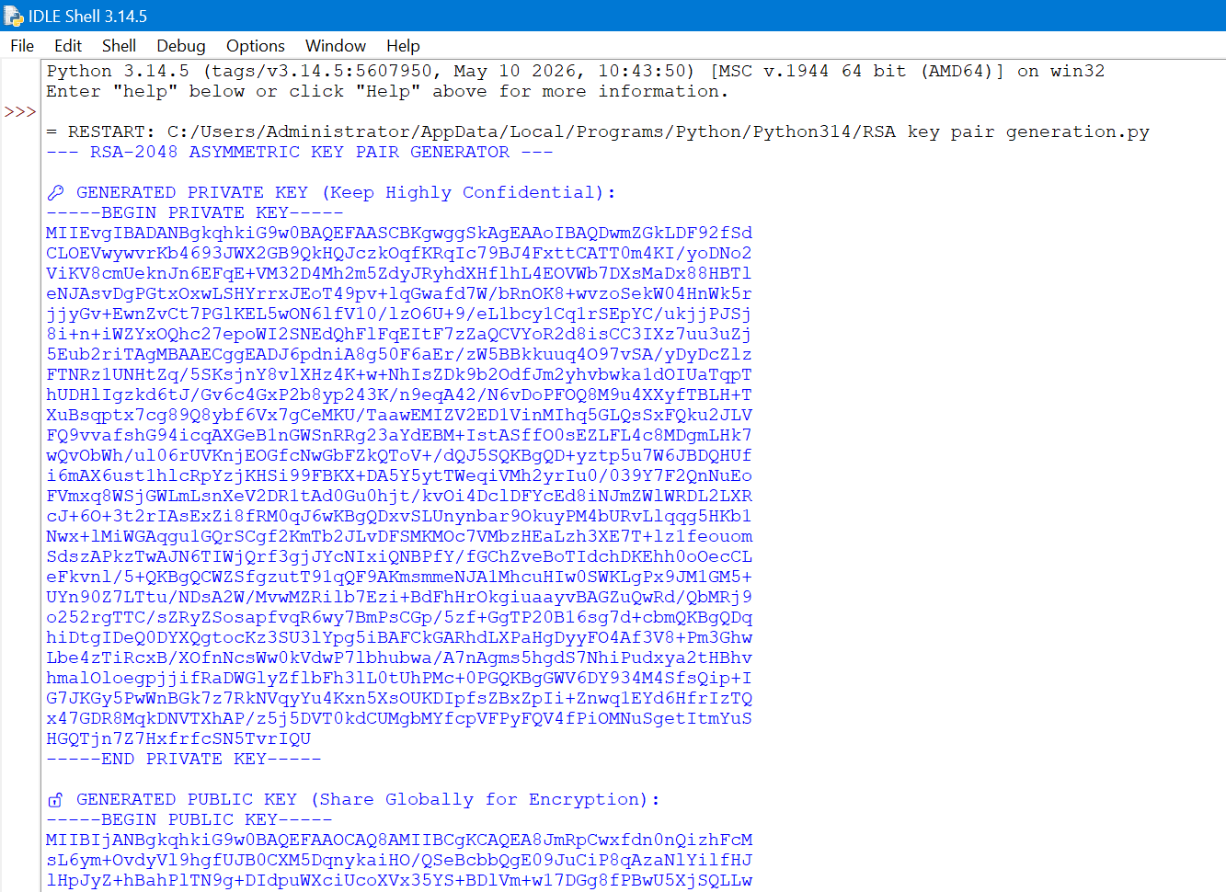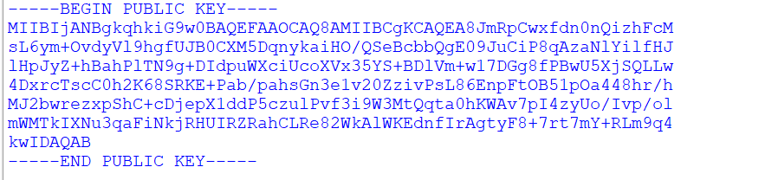

Fig 2: Public Key Encryption Process
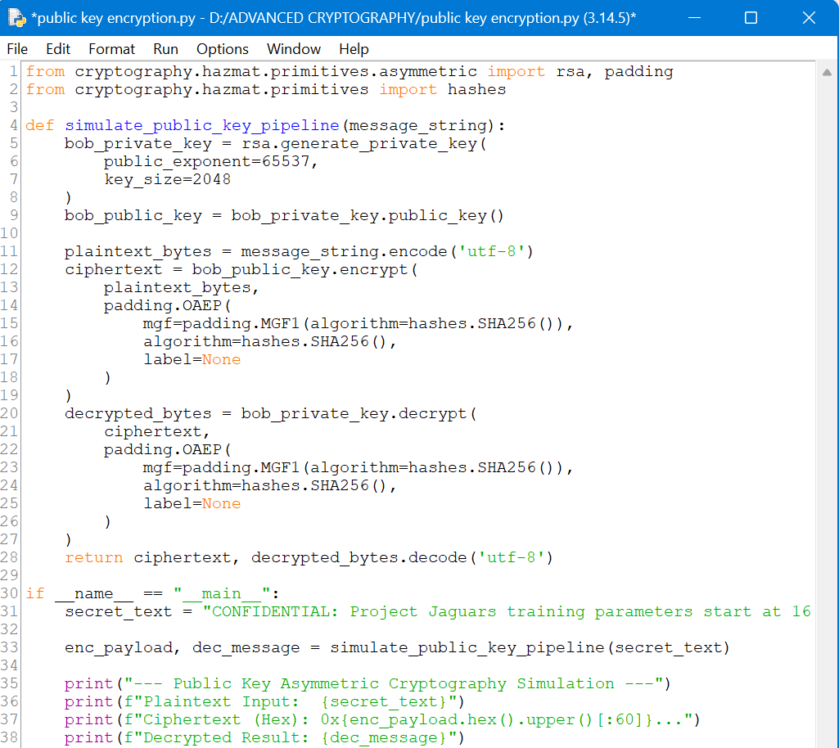
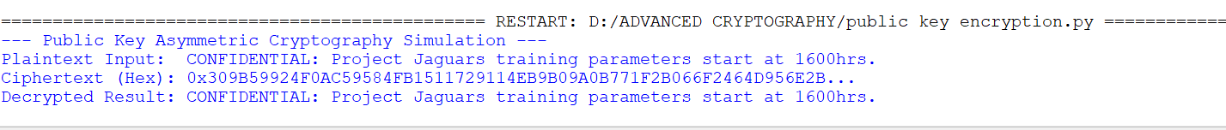

Fig 3: Private Key Decryption Results
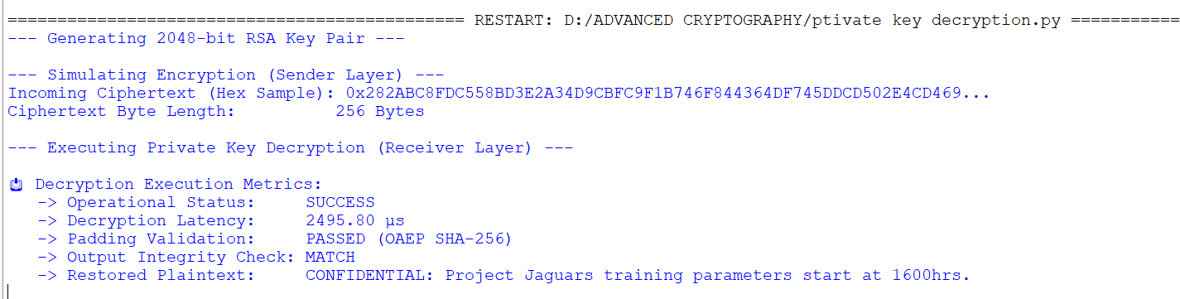

Fig 4: Secure Message Transmission
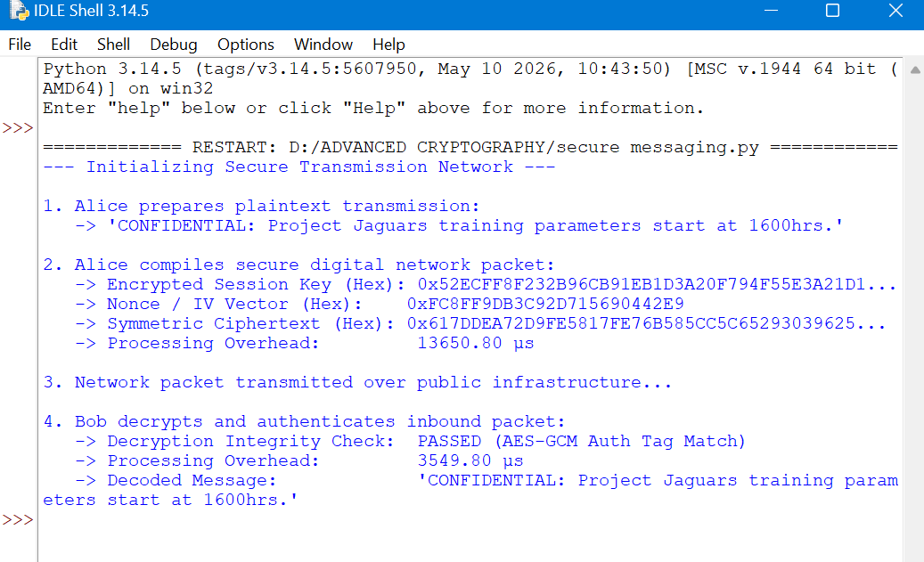

Fig 5: RSA Testing and Validation

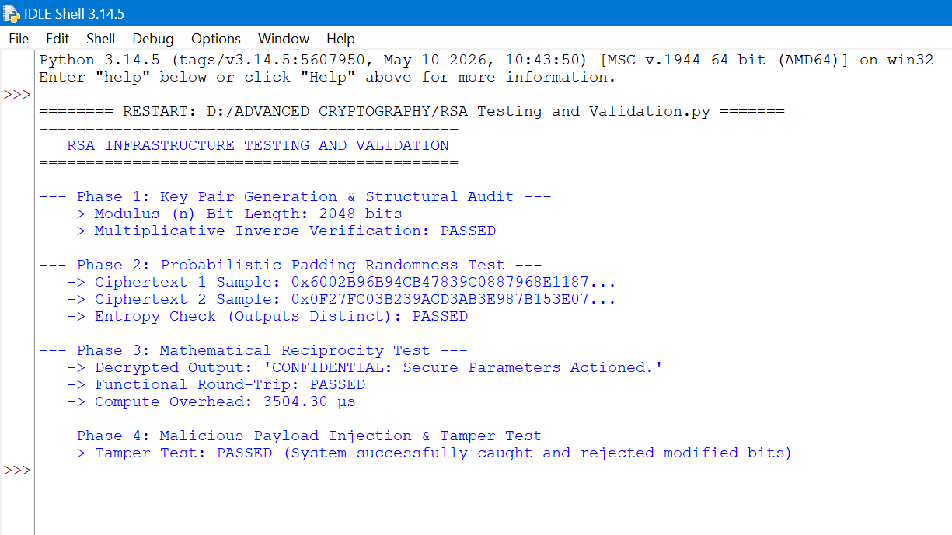

Creative implementation

Fig 6: Crypto Integrity Simulator
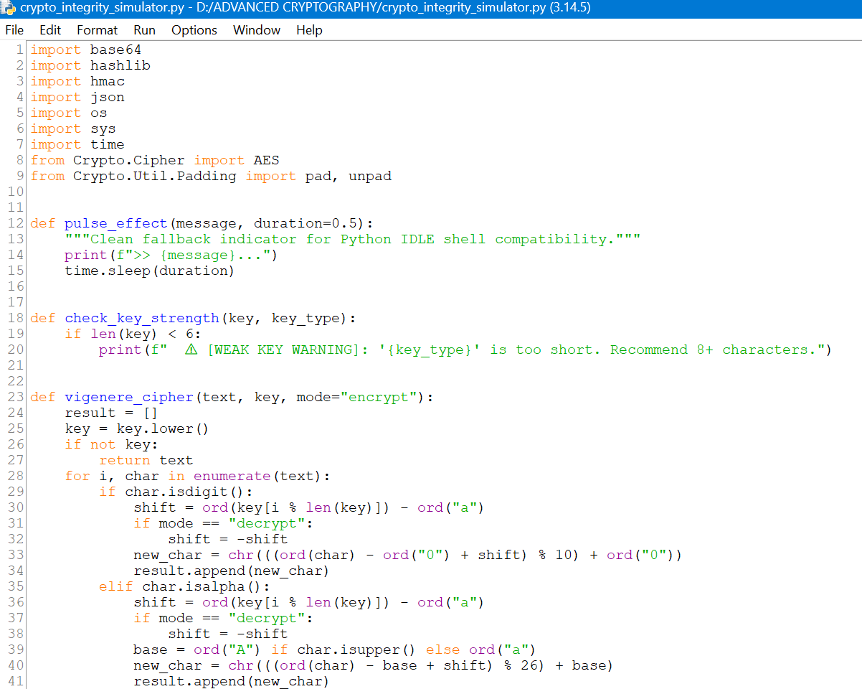
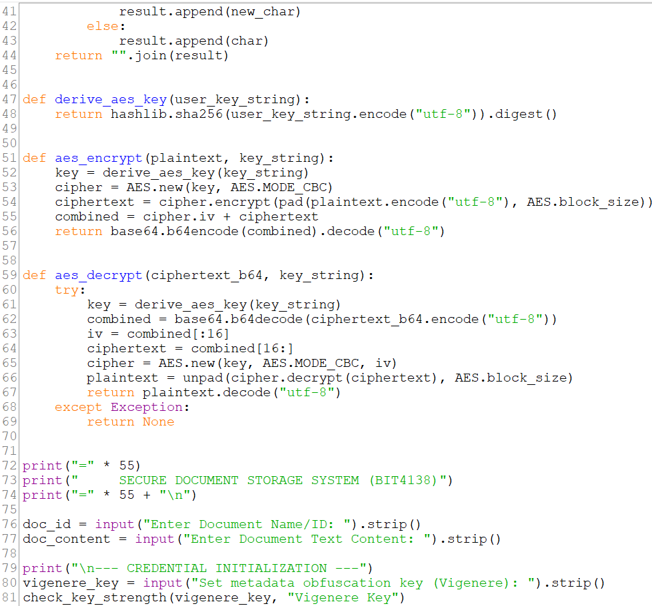
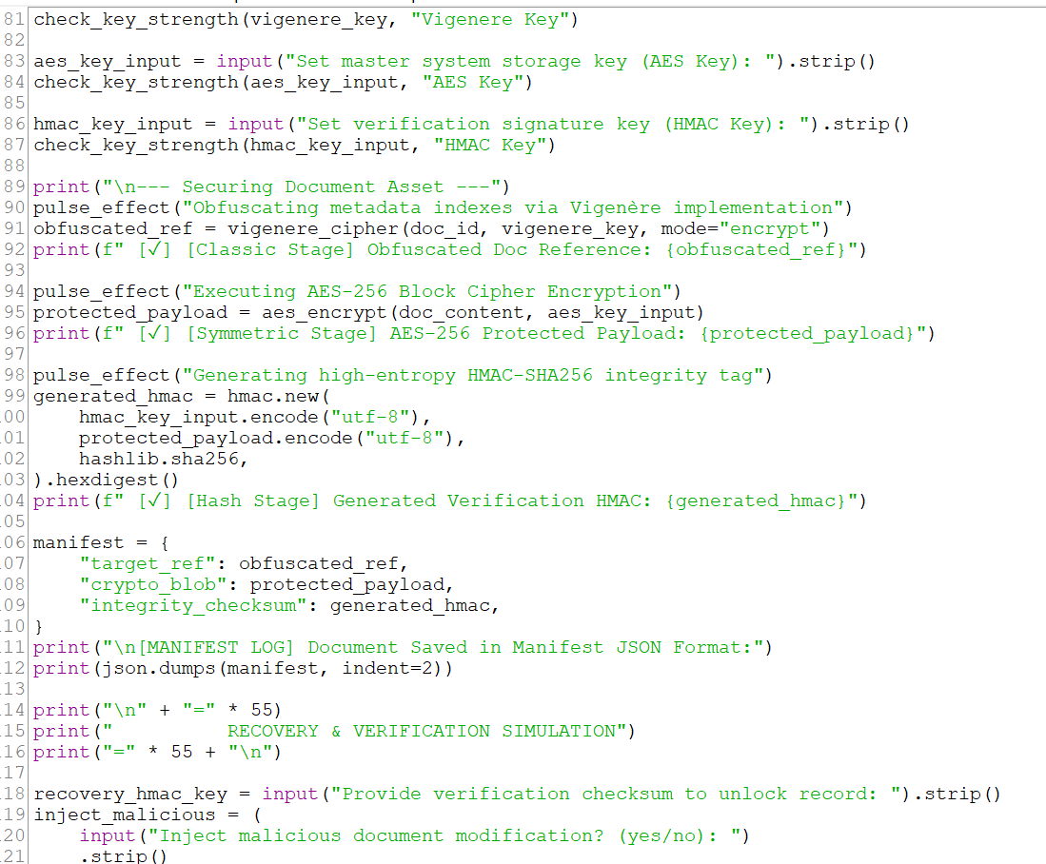
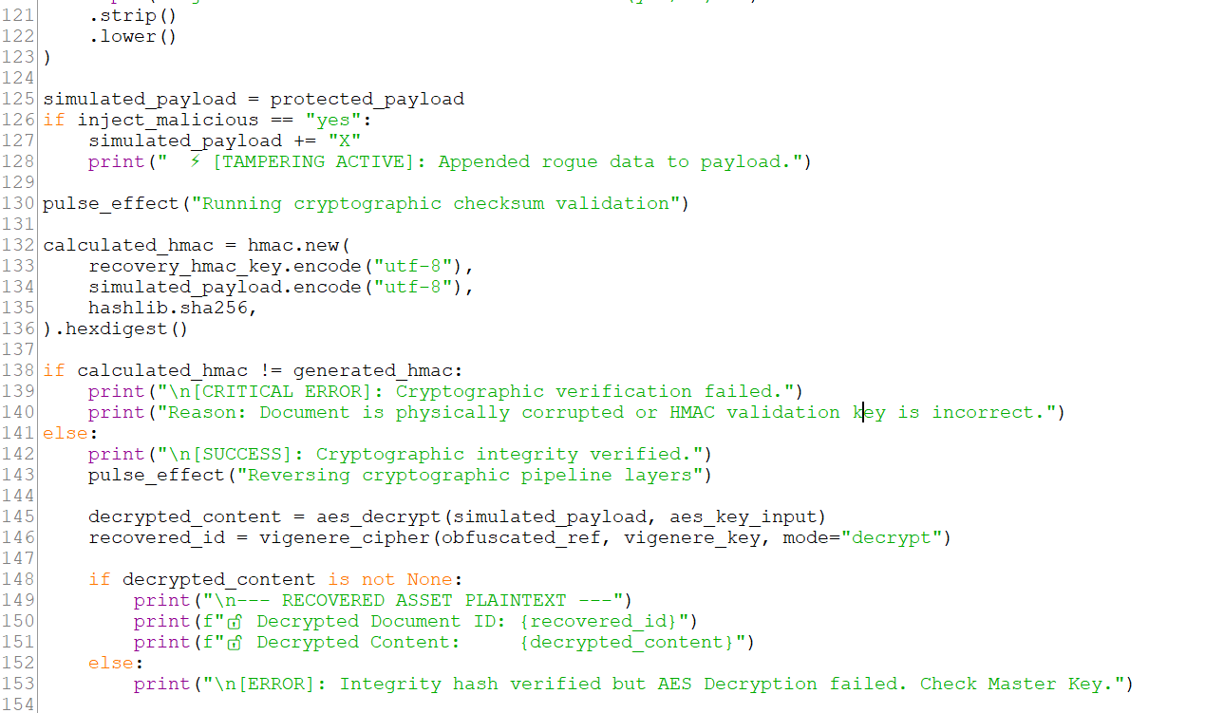
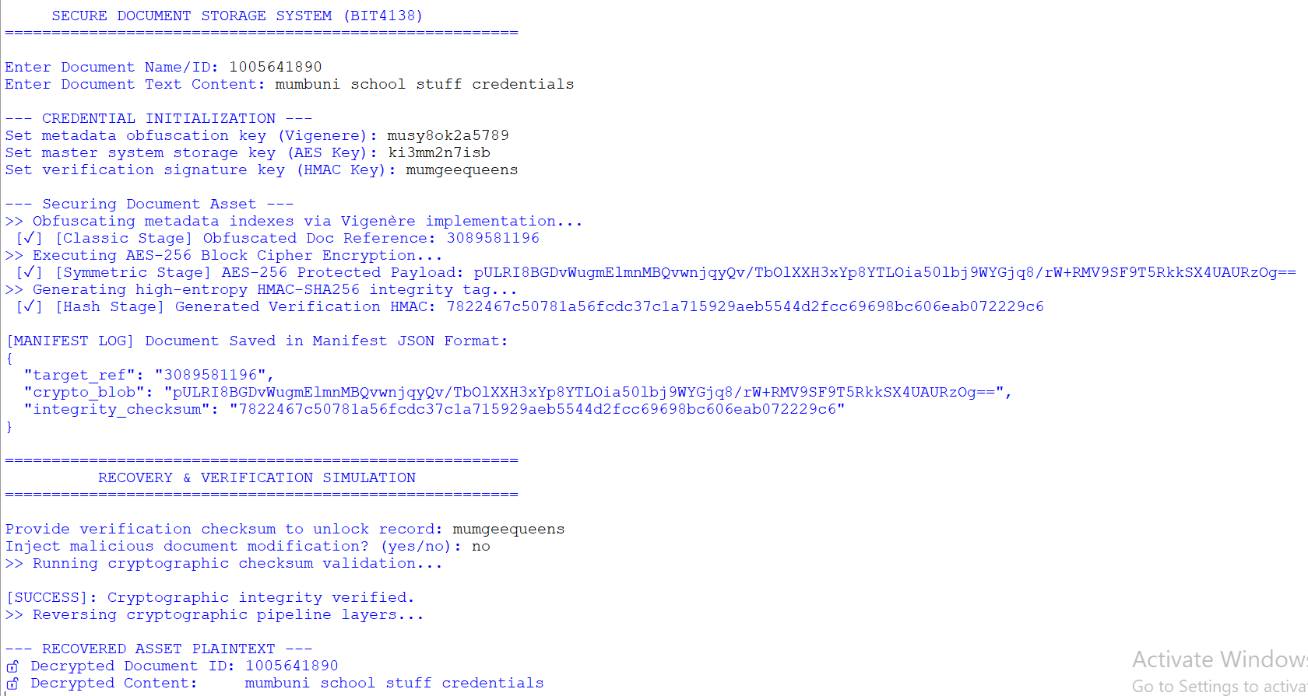
The system prompts the user to enter details of the document to be stored and it encrypts it and the user is required to enter the same verification checksum to unlock and decrypt the securely stored documents.

